**Organizational Structures**

**1. Functional organizational structure**

Summary

This structure groups the activity with same function or are of same in nature. These groups each have a manager known as Functional Manager such as Marketing manager, Sales manager etc, who is a subject matter expert in the concerned function and is responsible for the output of its department. These Functional Managers then report to a Higher Management on their progress.

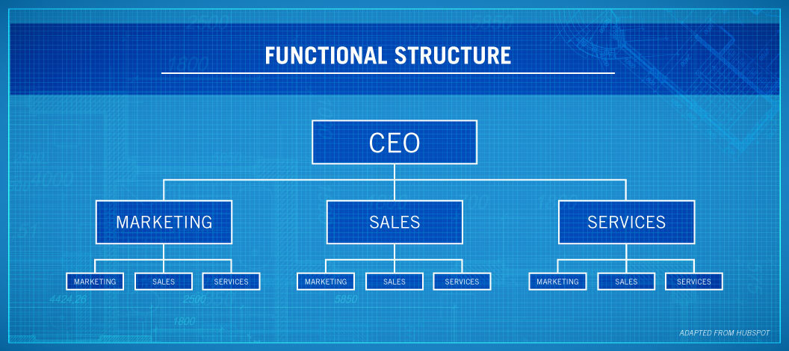

Pros :

* This grouping mechanism also groups the employees skilled in a particular function together resulting in higher successful outcome.
* The responsibilities are well defined and thus this results in easier management and accountability of the work assigned.
* There is a hierarchy and thus the communication is always in a straight line.
* No duplication of the job as each department is designed to work on a single function.
* The employees specialize in their own roles thus leading to employee job security.

Cons :

* Same kind of work gets monotonous over time.
* Resignation may cost the organization a skilled employee, one that cannot be easily replaced.
* Departments become self-centered, only concerned with their own workings and performance.
* No teamwork between the departments.
* Slow decision making due to bureaucracy.
* Employees have less margin to learn a different skill than their own since they first have to complete their own tasks each day.

When/When not to use:

Functional Structures are best used in smaller organizations with more simpler tasks. It should not be used with larger organizations as it may lead to these functional departments becoming more isolated and would start working as an independent smaller organization in themselves. It may be however used in larger organizations in cases where these are only responsible for producing fewer services or products.

**2. Divisional organizational structure**

Summary

This can be considered a modified version of the Functional Structure. Instead of separating the departments based just on their function the departments are categorized based on the product type, regions etc. Divisional structure provides each division with its own management hierarchy such as Commercial division General manager thus they are autonomous in themselves. Each division then has its own functional unit such as marketing, sales and services and they all report back to the division head.

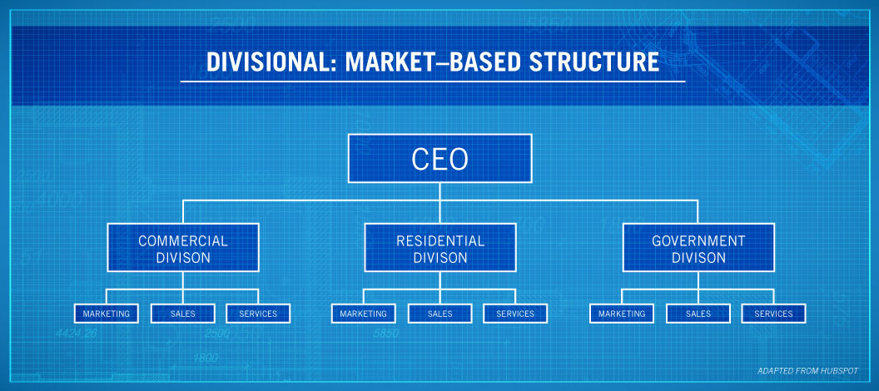

Pros :

* The divisions can be separated geographically and thus employees work in different work environments.
* It can be applied in larger organizations.
* Easy decision making since there is not a single centralized bureaucracy.

Cons :

* There may be competition among the divisions for company’s resources.
* It may result in duplicate or repetitive functions costing the organization financially as a whole.
* The company may lose its grip on the division as the inner workings and management are defined by and in control of the division head themselves.

When/When not to use:

Used in larger organizations with multiple products and services. In some cases it can also be used for smaller organizations with bigger projects.

**3. Matrix organizational structure**

Summary

Matrix organization is a hybrid organization and combination of two or more structures. These organizational structure help unify the other organizational structures within the organizations. Thus there could be two managers to a team i.e a Technical manager who is skilled in the function of the project and a Project manager who is concerned in keeping the objective of the project in check.

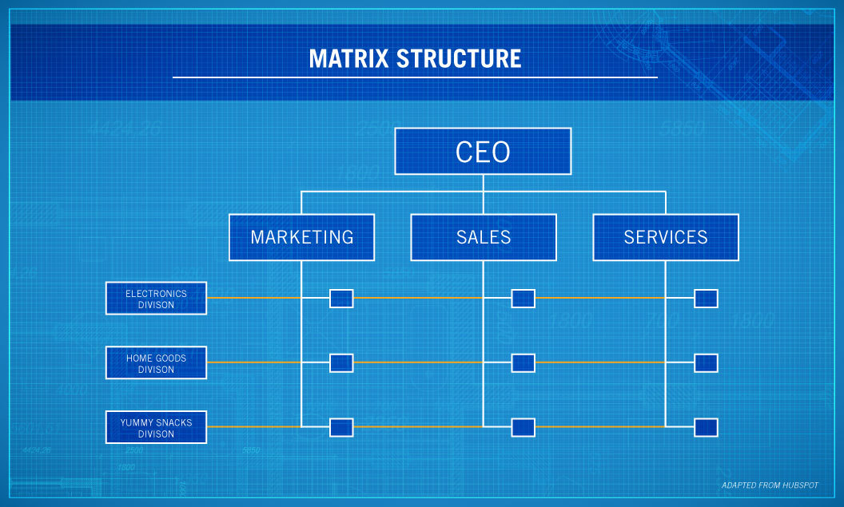

Pros :

* Exchange of resources is efficient.
* Optimal decision making since each Project manager looks over the project, discusses issues with the technical manager and also keeps the organization head in the loop .
* Easy team work between the departments or across teams.
* Healthy environment.

Cons :

* There are two managers to report and thus this results in confusion and conflicts as the difference in feedback to the worker may result in the conflict between the worker and that manager.
* The resources may not be fully utilized if the managers are unable to assign them correctly to the worker based on his/her skill.
* Multiple managers would increase the cost and utilization of the organizational resources.
* There could be differences between multiple managers.

When/When not to use:

When there are more larger and complex projects to deal with, a hierarchical structure may result in a slow decision rate. It looks for an alternative to organize the project instead of just following a single straight path.

**4.Network Organizational Structure**

Summary

It is the most recently developed and flat kind of structure. It easily maintains the integrity where the organization involves different locations. We can use company’s resources more freely and in the comfort of the home. As the image suggests these different locations are like arms and legs of the organization spread out with one main headquarters where the Company’s CEO resides and these other parts work at their separate locations and are connected by the organizations intra-network using VPN and communicating back and forth through mails, texts, company’s messenger services and video conferencing services such as zoom or WebEx.

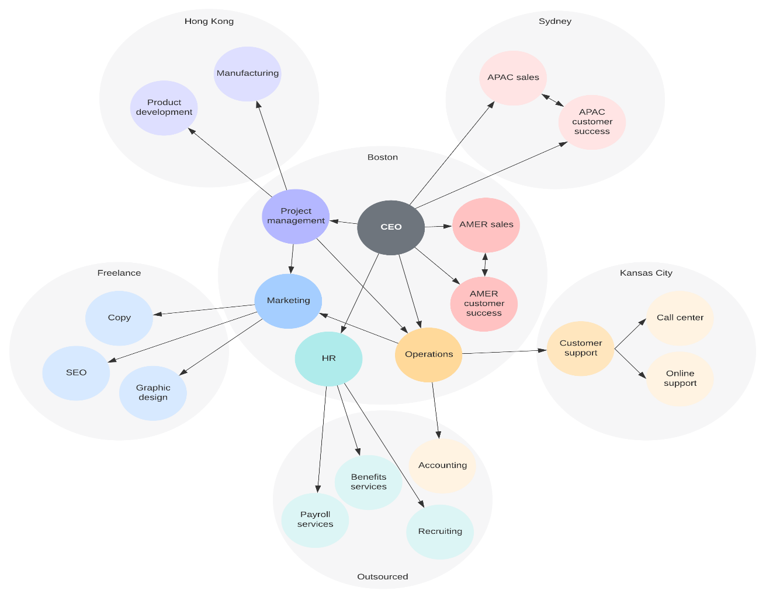

Pros :

* It is more cost friendly as communication is possible in any way.
* Flexible work hours, flexible network setup
* Inclusion of more types of people.

Cons :

* Lack of contact between the team members.
* Too much information sharing between different locations as there is nobody to supervise as such.
* Resources need to be made available in different geographical locations.
* Difference in time zones results in unsynchronized response times.

When/When not to use:

This is more useful for companies dealing in software products/services or IT industry. This is useful for organizations which are located in multiple continents and are ever growing in businesses such as the ones dealing in product development and customer services. Larger organizations however have to maintain a constant fluidity of resources among these locations to maintain parity in the organization.